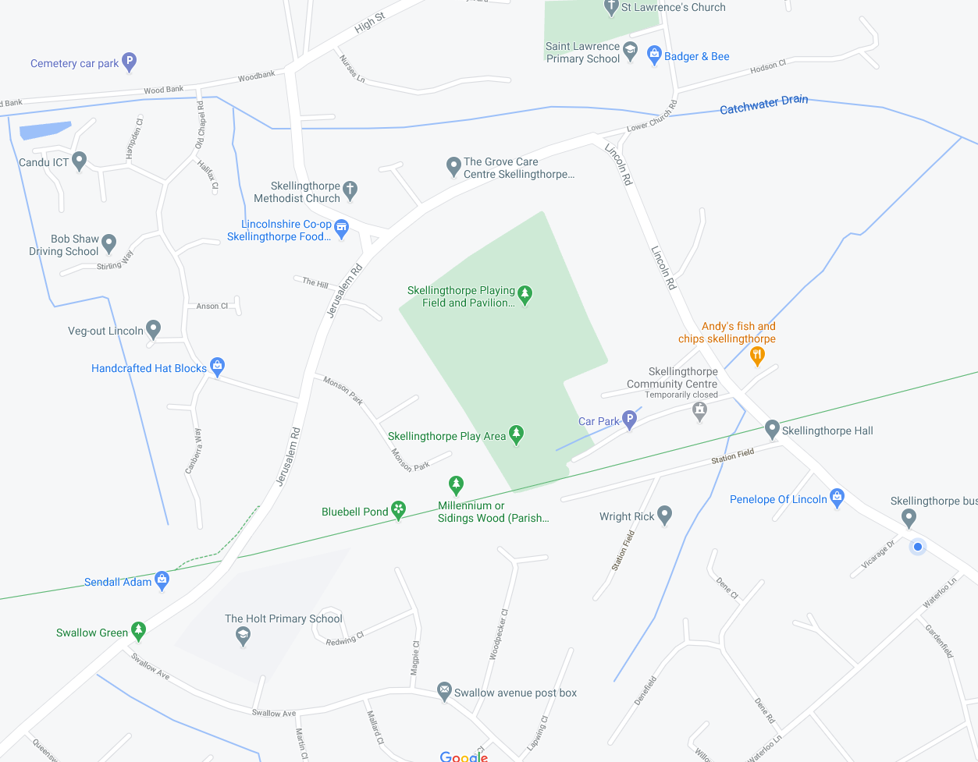

**Thanks for taking part, we hope you had fun! Don’t forget you can join us on Easter Sunday in person or online. All the details can be found on our website:**

**stlawrenceskellingthorpe.co.uk**

Letter

Letter

Letter

Letter

Letter

**Answer the question at each scene, plus find the 5 letters to complete the sentence: ‘Jesus is _ _ _ _ _.’**

**NO NEED TO DO IT IN ORDER 😊**

**1. Jesus enters Jerusalem**

*12 Dene Road, LN6 5SS*

Answer: ______________________________________________________________________________________________________

**2. Jesus’ last supper**

*The Methodist Church, 2High Street, LN6 5TR*

Answer: ______________________________________________________________________________________________________

**3. Jesus in the garden of Gethsemane**

*St Lawrence’s churchyard, LN6 5UZ*

Answer: ______________________________________________________________________________________________________

**4. Jesus on the cross**

*Four Oaks, 4a Waterloo Lane, LN6 5SL*

Answer: ______________________________________________________________________________________________________

**5. Jesus rose from the dead!**

*3 Halifax Close, LN6 5UG*

Answer: ______________________________________________________________________________________________________

**5**

**2**

**3**

**1**

**4**

29th March to 4th April 2021

**Easter Trail**